A

**PROPOSAL**

**ON**

**ESTABLISHMENT OF BIOGAS PLANT**

**AT NAGARKOT VILLAGE RESORT**

**Submitted to:**

**Mr. Bhaskar Shrestha**

**Manager**

**Nagarkot Village Resort**

**Submitted by:**

**Prabin Pradhananga (2070/BME/625)**

**Engineer**

**Altenative Energy Promotion Center(AEPC)**

**AUGUST 16, 2016**

**ABSTRACT**

Energy Crisis has become a common problem in our country. The Government of Nepal is not able to fulfill the growing energy demand. It is uncertain when the running hydroelectric projects will complete. Load shedding and fuel shortage have become the order of the day for every Nepali. It is the daily routine of Nepali to see the long endless line on roadside for the petroleum products. LPG price hike has further added problem in the life of the common people like us.

In this context, it has become inevitable to find a long term solution to this problem. The construction of biogas plant can help solve the issue up to some extent. Biogas is a clean fuel and can be produced by using wastages that are commonly found in our villages. One time investment can give desired results for years.

Biogas can help fulfill our daily energy demand for fuel. It has wide range of application. It can be used not only for cooking purpose but if produced in large volume, it can be utilized for lighting and transportation purposes too.

**TABLE OF CONTENTS**

|  |  |
| --- | --- |
| Topics | Page Number |
| Abstract | i |
| 1. Introduction | 1 |
| 1.1 Purpose | 1 |
| 1.2 Problems | 1 |
| 1.2.1 Increased fuel demand | 1 |
| 1.2.2 High Costs | 1 |
| 1.2.3 Increased Risks | 1 |
| 2. Discussion | 2 |
| 2.1 Technical Description | 2 |
| 2.1.1 Principle of biogas generation | 2 |
| 2.1.2 Components of biogas plant | 2 |
| 2.1.3 Detailed design of biogas plant | 3 |
| 2.2 Personnel | 4 |
| 2.3 Cost/budget | 5 |
| 3. Conclusion | 6 |
| 4. Recommendations | 7 |
| 5. References | 8 |

**LIST OF ILLUSTRATIONS**

|  |  |  |
| --- | --- | --- |
| Number | Description | Page Number |
| Figure 1 | Energy Consumption in Nepal | 1 |
| Figure 2 | General Principle of biogas generation | 2 |
| Figure 3 | Working reaction of biogas | 3 |
| Figure 4 | Proposed design of Biogas plant | 4 |
| Table 1 | Cost Estimation | 5 |

1. **INTRODUCTION**

**1.1 PURPOSE**

This is a proposal to construct a scientifically advanced and efficient biogas plant at Nagarkot Village Resort, Bhaktapur. This can help you to deduct your investment in fuel and electricity and thus you can minimize your expenses.

**1.2 PROBLEMS**

**1.2.1 Increased fuel demand:**

The consumption of energy is increasing day by day. The ratio of consumption and supply of energy had very big gap between them. The consumption rate is increasing rapidly. The consumption of petroleum products in FY 2006/07 had increased by 0-7. The consumption of LP gas had increased by 29.8 percent in the first eight months of FY 2007/08.

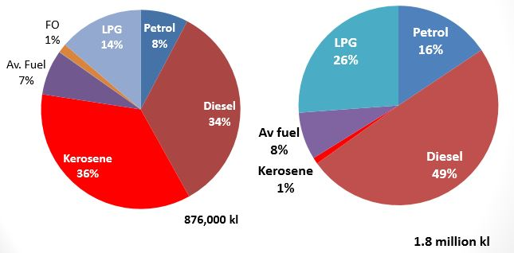

20042015

Figure 1: Energy Consumption In Nepal

**1.2.2 High Costs:**

The cost of fuel has skyrocketed since recent years. Nepalese are compelled to pay high costs for fuel and electricity.

**1.2.3 Increased Risk:**

The cases of LPG cylinder burst have increased since few years and it has become risky to use it. The manufacturing company is not paying proper attention in testing the cylinder.

1. **DISCUSSION**

**2.1 TECHNICAL DESCRIPTION**

**2.1.1 Principle of biogas generation:**

It is gas produced by the breakdown of organic matters in absence of gaseous oxygen and at the same time in presence of anaerobic bacteria. It contains methane in majority (55-60%), than carbon dioxide (30-40%) and as impurities hydrogen, hydrogen sulphide and trace amount of nitrogen. Generation of biogas is concerned with micro-organisms. The basic idea is that it is generated from decomposition of animal, plant, human and industrial wastes. Biogas is practically generated as landfill gas in a container called DIGESTER.

**2.1.2 Components of biogas plant**

• Digestion Chamber:

Chamber where anaerobic condition is ensured and organic matter is digested by methanogenic bacteria should be air tight

• Inlet:

To feed organic matter into digestion chamber

• Outlet:

To remove digested matter, i.e., slurry

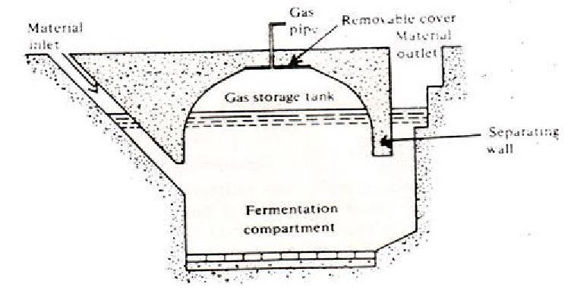

Figure 2: General Principle of biogas generation

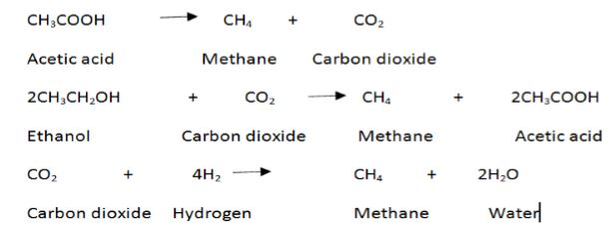

Figure 3: Working reaction of biogas

**2.1.3 Detailed design of Biogas plant:**

The general working principle of biogas plant is described below:

* Slurry (mixture of equal quantities of biomass and water) is prepared in the mixing tank.
* The prepared slurry is fed into the inlet chamber of the digester through the inlet pipe.
* The plant is left unused for about two months and introduction of more slurry is stopped.
* During this period, anaerobic fermentation of biomass takes place in the presence of water and produces biogas in the digester.
* Biogas being lighter rises up and starts collecting in the gas holder. The gas holder now starts moving up.
* The gas holder cannot rise up beyond a certain level. As more and more gas starts collecting, more pressure begins to be exerted on the slurry.
* The spent slurry is now forced into the outlet chamber from the top of the inlet chamber.
* When the outlet chamber gets filled with the spent slurry, the excess is forced out through the outlet pipe into the overflow tank. This is later used as manure for plants.
* The gas valve of the gas outlet is opened to get a supply of biogas.
* Once the production of biogas begins, a continuous supply of gas can be ensured by regular removal of spent slurry and introduction of fresh slurry.

**Advantages:** Simple, easily understood operation, constant gas pressure, volume of stored gas visible directly, few mistakes in construction.

**Disadvantages:** High construction cost of floating-drum, many steel parts liable to corrosion, resulting in short life due to painting.

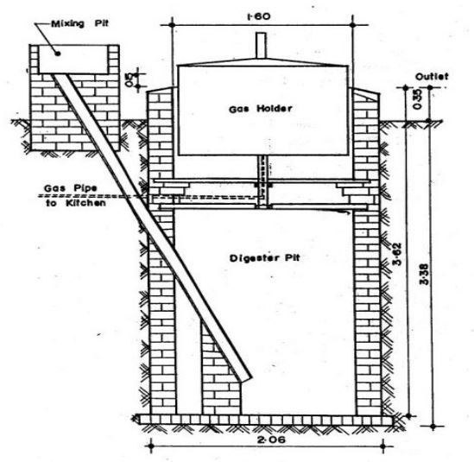

Figure 4: Proposed design of Biogas plant

**2.2 PERSONNEL**

Each of our engineering facilities is staffed by trained technicians who are cooperative and have finest knowledge in the field of biogas construction.

**Er. Prashant Neupane**

Er. Prashant Neupane(B.E. Mechanical Engineering, IOE, Pulchowk Campus) has worked at Alternative Energy Promotion Center since 2010. He has specialized knowledge in 3D simulation and design. He has sound knowledge of engineering softwares like AutoCAD, Solidworks, CATIA, etc.

**Er. Gopal Shrestha**

Er. Gopal Shrestha(BE Civil Engineering, IOE, Pulchowk Campus) has worked at Alternative Energy Promotion Center since 2012. He has specialized knowledge in civil engineering aspects associated with the construction of biogas.

**2.3 COST/BUDGET:**

AEPC is pleased to offer you with our modern biogas equipment and at cost-effective pricing. Table 1 explains the benefits you will derive when purchasing and during the construction perid.

**S. No. Components Capital Cost per unit(NRs.)**

1. Gas holder, frame, pressure gauge 5000

2. Piping and stove 2000

3. Floating Drum 8000

4. Civil Engineering Construction (inlet, outlet, brick, sand) 5000

5. Cement 8000

Total 28000

Table 1: Cost Estimation

**Payback period**

Let us look at the saving due to the use of the biogas. Assuming that the biogas is replacing the use of LPG, following calculations can be done to calculate the amount of savings.

* The total amount of LPG requied is about 2 kg/month/per person.
* Total LPG required for 6 people for a month is = 6*2 = 12 kg per month.
* Cost of LPG per kg is about Rs.100.
* Total cost of LPG(if used instead of biogas)=12*100=Rs.1200 per month(this amount is monthly saving).
* Total yearly saving=1200*12=Rs.14400 per year.
* Therefore, simple payback period is= total cost of biogas plant/yearly savings=28000/14400=2 years(approx.)

1. **CONCLUSION**

Use of clean fuel like biogas not only conserves the environment but also helps in reducing our fuel expenses. The investment cost is simply returned within few years of construction. It can help us deal with the problem of fuel crisis and price hike. One does not need to rely on the government for daily fuel needs.

1. **RECOMMENDATION**

To deal with the rising fuel crisis and price hike, we highly recommend the construction of biogas plant.

1. **REFERENCES**

* Solanki, C. S. (2009). Renewable Energy Technologies. New Delhi: PHI Learning Pvt. Ltd.